SET-1
MARKS: 70
Class XII BIOLOGY (044) Max Time: 3 hours

General Instructions:
- There are a total of 27 questions and five sections in the question paper. All questions are compulsory.
- Section A contains question numbers 1 to 5, multiple choice questions of one mark each. Section B contains question numbers 6 to 12, short answer type I questions of two marks each. Section C contains question numbers 13 to 21, short answer type II questions of three marks each.
Section D contains question number 22 to 24, case-based short answer type questions of three marks each.
Section E contains question numbers 25 to 27, long answer type questions of five marks each.
- There is no overall choice in the question paper. However, internal choices are provided in two questions of one mark, one question of two marks, two questions of three marks and all three questions of five marks. An examinee is to attempt any one of the questions out of the two given in the question paper with the same question number.

SECTION A

  - Which of the following ecosystem is most productive in terms of net primary production?
    - Desert
    - Tropical Rain Forest
    - Oceans
    - Estuaries
OR
The extinction of passenger‟s pigeon was due to
- Increased number of predatory birds
- Over exploitation by human
- Non availability of food
- Co-extinction

  - Total amount of Adenine in double stranded DNA is 45%. The amount of guanine in the DNA would be
    - 5%

b) 55%
c) 45%
d) 10%
OR
In a DNA Strand the nucleotides are linked together by
- Peptide bonds
- Hydrogen bonds
- Glycosidic bonds
- Phospho diester bonds

  - The stimulant cocaine is obtained from
    - Rauwolfia
    - Erythroxylon
    - Papaver
    - Cannabis

  - Given below are a few statements related to external fertilization. Choose the correct statements
- The male and female gametes are formed simultaneously
- Only a few gametes are released in to the medium
- Water is the medium in a majority of organisms exhibiting external fertilization
- Offspring as a result of external fertilization have better chance of survival than those formed inside an organism

  - iii & iv
  - i & iii
  - ii & iv
  - i & iv

  - For the MN blood group system, the frequencies of M & N alleles are 0.7 and 0.3 respectively.
The expected frequency of MN blood group bearing organisms is likely to be a) 42%
b) 49%
c) 24%
d) 58%

SECTION B

  - A herd of cattle showing reduced fertility and productivity. Provide one reason and one suggestion to overcome this problem.
OR

How did plant breeding technique help North Indian farmers to develop Sugar cane with desirable characters?

  - How did a citizen group called “Friends of Arcata Marsh”, Arcata, California, USA help to improve water quality of marsh land using integrated waste water treatment? Explain four steps.

  - A mature embryosac in flowering plant may possess seven cells, but eight nuclei. Explain with the help of a diagram.

  - How do Mycorrhizae help the plants to grow better?

  - If a father and son, both are defective in red-green colour vision, Is it likely that the Son inherited the trait from his father? Comment.

  - In Pea tallness is dominant over dwarfness and violet colour of flower is dominant over the white colour. When a tall plant bearing violet flowers was pollinated with dwarf plant bearing white flowers, the different phenotypic groups were obtained in the progeny in numbers mentioned against them
Tall Violet 138
Tall White 135
Dwarf Violet 136
Dwarf White 132
Mention the genotype of the two parents and the 4 offspring types.

  - Besides better aeration and mixing properties, what other advantages do stirred tank bio reactors have over shake flasks?

SECTION C

  - A number of passengers were severely burnt beyond recognition during a train accident. Name and describe a modern technique that can help hand over the dead to their relatives

  - Describe how do „Flocs‟ and „Activated Sludge‟ help in Sewage treatment.

OR

Write the most important characteristic that (a) Aspergillus niger, (b) Monascus purpureus and
(c) Saccharomyces cerevisiae, share.

  - List three strategies that bisexual chasmogamous flowers can evolve to prevent self pollination or autogamy.

  - You are planning to set up dairy farm. Describe the various aspects you would consider before you start the venture.

  - Explain briefly the „Rivet Popper‟ hypothesis of Paul Ehrlich.

  - For selection of recombinants, insertional inactivation of antibiotic marker has been super ceded by insertional inactivation of a marker gene coding for a chromogenic substrate. Give reasons

  - a. What precaution would you recommend to a patient requiring repeated blood transfusion?

b. If the advice is not followed by the patient, there is an apprehension that the patient might contract a disease that would destroy the immune system of his/her body. Explain with the help of schematic diagram only how the immune system would get affected and destroyed.

  - The zygote of human passes through several developmental stages till implantation. Describe each stage briefly with suitable diagrams.
OR
Meiotic division during Oogenesis is different from that in spermatogenesis. Explain how and why.

  - Define Aneuploidy. How is it different from Polyploidy? Briefly explain the indviduals having following chromosomal abnormalities.
    - Trisomy of 21st chromosome
    - XXY
    - XO

SECTION D

  - Observe figure and answer the following questions.

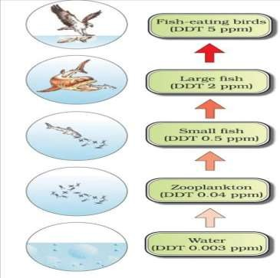

- What ecological term is used to describe DDT accumulation at different trophic level?
- List any one effect of DDT accumulation on birds.
- Will DDT accumulation lead to eutrophication?
- Does it affect the BOD?

  - Observe the diagram and answer the following
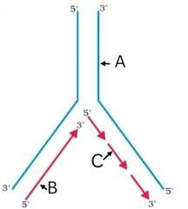
    - What does the picture represent?

    - Identify A, B & C.
    - Name any two enzymes needed for this process.

  - Analyze the graph and answer the questions based on it.

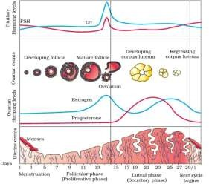
- When does the secretion of LH & FSH attain its peak level? What is the result of rapid secretion of LH?
- When does the level of Progesterone rise? Why it is essential?
- A proper understanding of menstrual cycle can help immensely in family planning. Do you agree with the statement? Provide reasons for your answer.

SECTION E

  - a) Draw a diagram of an enlarged view of TS of one microsporangium of angiosperm and label the following parts
- Tapetum
- Middle layers
- Endothecium
- Microspore mother cells.

- Mention the characteristic features and function of tapetum.
- Explain the following giving reasons.
- Pollen grains are well preserved as fossils.
- Pollen tablets are in use by people these days.

OR
Read the statement and answer the questions that follows.
“A flower of tobacco has 120 ovules in its ovary. However, it produces a fruit with only 100 viable seeds.”

- What could have prevented the rest 20 ovules from maturing in to viable seeds? Explain giving reasons.
- Briefly describe the development of dicot embryo in a viable seed.
- Why certain angiospemic seeds are albuminous while others are ex-albuminous? Explain.

  - a) How has the use of Agrobacterium tumifaciens as vector helped in controlling Meloidegyne incognitia infestation in tobacco plants? Explain in correct sequence.

- Describe the responsibility of GEAC, set up by Indian Government.

- How is „Rosie‟ considered different from a normal cow?

OR

- Explain briefly PCR Technique by diagrammatic representation.

- Why a patient of ADA deficiency requires repeated infusion of genetically engineered lymphocytes? Suggest a possible permanent remedy.

  - a) Following are the responses of different animals to various abiotic factors. Describe each one with the help of an example
- Regulate
- Conform
- Migrate
- Suspend

b) If 8 individuals in a population of 80 butterflies die in a week, calculate the death rate of population of butterflies during that period.

OR

- What is a trophic level in an ecosystem? What is „standing crop‟ with reference to it?
- Explain the role of the „first trophic level‟ in an ecosystem.
- How is the detritus food chain connected with the grazing food chain in a natural ecosystem?

